Unit 8: Our Genetic Future

Section I: Human Genetics Pages 2 - 3

Section II: Genetic Disorders Pages 4 – 6

Section III. Biotechnology Pages 6 – 9

Section IV. Ethical, Legal and Sociatal Issues Pages 9 – 11

Section V. Glossary Page 12

9-12.N.1.1. Students are able to evaluate a scientific discovery to determine and describe how
societal, cultural, and personal beliefs influence scientific investigations and interpretations.
9-12.L.2.1. Students are able to predict inheritance patterns using a single allele.
9-12.L.2.2. Students are able to describe how genetic recombination, mutations, and natural selection
lead to adaptations, evolution, extinction, or the emergence of new species.
9-12.S.1.2. Students are able to evaluate and describe the impact of scientific discoveries on historical
events and social, economic, and ethical issues.

Prefix/Suffix | Definition
Homo- | Same
Bio- | Life
-ology | Study of
Trans- | Across, Between
Key Vocabulary Terms

1. Biotechnology
2. Chromosome
3. Cloning
4. Genome
5. Genetically Modified Organism
6. Karyotype
7. Mutation
8. Stem Cell

I. Human Genetics

Nobody else in the world is exactly like you. What makes you different from everyone else? Genes have a lot to do with it. Unless you have an identical twin, no one else on Earth has exactly the same genes as you. What about identical twins? Are they identical in every way? They develop from the same fertilized egg, so they have all same genes, but even they are not completely identical. Why? The environment also influences human characteristics, and no two people have exactly the same environment.

The Human Genome
All of the DNA of the human species makes up the human genome. This DNA consists of about 3 billion base pairs and is divided into thousands of genes on 23 pairs of chromosomes. Thanks to the Human Genome Project, scientists now know the DNA sequence of the entire human genome. The Human Genome Project is an international project that includes scientists from around the world. It began in 1990, and by 2003, scientists had sequenced all 3 billion base pairs of human DNA. Now they are trying to identify all the genes in the sequence. The human genome project was unique due to its collaborative nature; numerous countries agreed to share their research data on the internet so all researchers would have access to this valuable resource.

- Human Genome Project link: http://www.pbs.org/wgbh/nova/genome/program.html.

Why did countries decide to freely share the research result of the Human Genome Project?

Chromosomes and Genes
Each species has a characteristic number of chromosomes. The human species is characterized by 23 pairs of chromosomes, as shown in Figure 1.

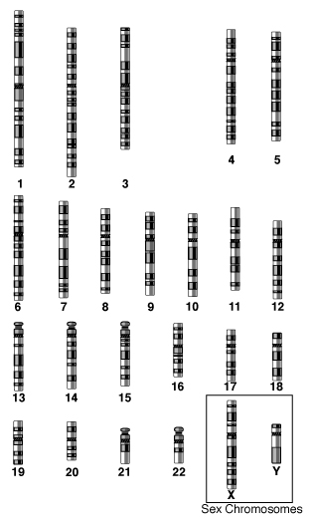
Figure 1. Human Chromosomes.
Human chromosomes are shown here arranged by size. Chromosome 1 is the largest, and chromosome 22 is the smallest. All normal human cells (except gametes) have two of each chromosome, for a total of chromosomes per cell. Only one of each pair is shown here.
Autosomes
Of the 23 pairs of human chromosomes, 22 pairs are autosomes (numbers 1–22). Autosomes are chromosomes that contain genes for characteristics that are unrelated to sex. These chromosomes are the same in males and females. The great majority of human genes are located on autosomes.

Sex Chromosomes
The remaining pair of human chromosomes consists of the sex chromosomes, X and Y. Females have two X chromosomes, and males have one X and one Y chromosome. In females, one of the X chromosomes in each cell is inactivated and known as a Barr body. This ensures that females, like males, have only one functioning copy of the X chromosome in each cell. As you can see from Figure 1, the X chromosome is much larger than the Y chromosome. The X chromosome has about 2,000 genes, whereas the Y chromosome has fewer than 100, none of which are essential to survival. Virtually all of the X chromosome genes are unrelated to sex. Only the Y chromosome contains genes that determine sex. A single Y chromosome gene, called SRY (which stands for sex-determining region Y gene), triggers an embryo to develop into a male. Without a Y chromosome, an individual develops into a female, so you can think of female as the default sex of the human species.

Why would it be a problem if many vital genes were found only on the Y chromosome?

Human Genes
Humans have an estimated 22,000 genes. This may sound like a lot, but it really isn’t. Far simpler species have almost as many genes as humans. However, human cells use splicing and other processes to make multiple proteins from the instructions encoded in a single gene. Of the 3 billion base pairs in the human genome, only about 25 percent make up genes and their regulatory elements. The functions of many of the other base pairs are still unclear.

The majority of human genes have two or more possible alleles. Differences in alleles account for the considerable genetic variation among people. In fact, most human genetic variation is the result of differences in individual DNA bases within alleles.

The ultimate result of the Human Genome Project was a map of each of our 23 chromosomes. Figure 2 illustrates a few of the genes found on the human X chromosome. Chromosome maps have allowed for the development of tests for certain genetic traits.

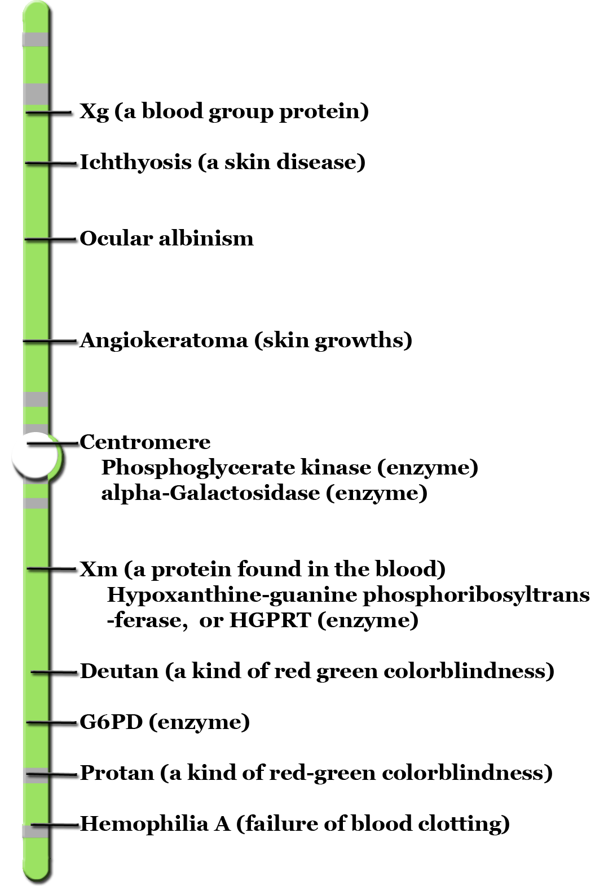
Figure 2. Linkage Map for the Human X Chromosome
This linkage map shows the locations of several genes on the X chromosome. Some of the genes code for normal proteins. Others code for abnormal proteins that lead to genetic disorders.

You can click on any human chromosome at this link to see the genetic disorders associated with it:
http://www.ornl.gov/sci/techresources/Human_Genome/ posters/chromosome/chooser.shtml

II. Genetic Disorders

Most genetic disorders are caused by mutations in one or a few genes. Other genetic disorders, known as chromosomal disorders, are caused by abnormal numbers of chromosomes.

Genetic Disorders Caused by Mutations
Table 1 lists several genetic disorders caused by mutations. Some of the disorders are caused by mutations in autosomal genes, others by mutations in X-linked genes.

Table 1. This table describes several genetic disorders caused by mutations in just one gene. Which disorder would you expect to be more common in males than females.
Genetic Disorder | Direct Effect of Mutation | Signs and Symptoms of the Disorder | Mode of Inheritance
Marfan syndrome | defective protein in connective tissue | heart and bone defects and unusually long, slender limbs and fingers | autosomal dominant
Sickle cell anemia | abnormal hemoglobin protein in red blood cells | sickle-shaped red blood cells that clog tiny blood vessels, causing pain and damaging organs and joints | autosomal recessive
Vitamin D-resistant rickets | lack of a substance needed for bones to absorb minerals | soft bones that easily become deformed, leading to bowed legs and other skeletal deformities | X-linked dominant
Hemophilia A | reduced activity of a protein needed for blood clotting | internal and external bleeding that occurs easily and is difficult to control | X-linked recessive

- You can watch a video about genetic disorders caused by mutations at this link:
http://www.pbs.org/wgbh/nova/programs/ht/rv/2809_03.html.

Few genetic disorders are controlled by dominant alleles. A mutant dominant allele is expressed in every individual who inherits even one copy of it. If it causes a serious disorder, affected people may die young and fail to reproduce. Therefore, the mutant dominant allele is likely to die out of the population. A mutant recessive allele, such as the allele that causes cystic fibrosis, is not expressed in people who inherit just one copy of it. These people are called carriers. They do not have the disorder themselves, but they carry the mutant allele and can pass it to their offspring. Thus, the allele is likely to pass on to the next generation rather than die out.

Huntington’s Chorea is a disease caused by a dominant allele. The disease causes nerve and muscle problems, ultimately leading to death. However, the disease doesn’t show up until the age of 40 or 50. Why has this fatal disease, caused by a dominant allele, not been eliminated from the human gene pool?

Chromosomal Disorders
Mistakes may occur during meiosis that result in nondisjunction. This is the failure of homologous chromosomes to separate during meiosis (the following animation shows how this happens:
http://learn.genetics.utah.edu/content/begin/traits/predictdisorder/index.html ). Some of the resulting gametes will be missing a chromosome, while others will have an extra copy of the chromosome. If such gametes are fertilized and form zygotes, they usually do not survive. If they do survive, the individuals may have serious genetic disorders. Table 2 lists several genetic disorders that are caused by abnormal numbers of chromosomes. These conditions are known as chromosomal disorders.

Table 2 Having the wrong number of chromosomes causes the genetic disorders described in this table. Most chromosomal disorders involve the X chromosome. The X and Y chromosomes are very different in size, so nondisjunction of the sex chromosomes occurs relatively often.

Genetic Disorder | Genotype | Phenotypic Effects
Down syndrome | extra copy (complete or partial) of chromosome 21 (Figure 3) | developmental delays, distinctive facial appearance, and other abnormalities (Figure 3)
Turner’s syndrome | one X chromosome but no other sex chromosome (XO) | female with short height and infertility (inability to reproduce)
Triple X syndrome | three X chromosomes (XXX) | female with mild developmental delays and menstrual irregularities
Klinefelter’s syndrome | one Y chromosome and two or more X chromosomes (XXY, XXXY) | male with problems in sexual development and reduced levels of the male hormone testosterone

Diagnosing Genetic Disorders
A genetic disorder that is caused by a mutation can be inherited. Therefore, people with a genetic disorder in their family may be concerned about having children with the disorder. Professionals known as genetic counselors can help them understand the risks of their children being affected. If they decide to have children, they may be advised to have prenatal (“before birth”) testing to see if the fetus has any genetic abnormalities. One method of prenatal testing is amniocentesis. In this procedure, a few fetal cells are extracted from the fluid surrounding the fetus, and the fetal chromosomes are examined. When all chromosomes are imaged and paired, the result is a picture known as a karyotype. Figure 3 is an image of a karyotype of a Down’s Syndrome individual.

Figure 3. Trisomy 21 (Down Syndrome) Karyotype. A karyotype is a picture of a cell's chromosomes. Note the extra chromosome 21.
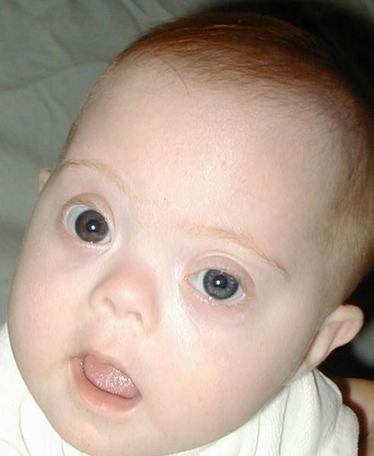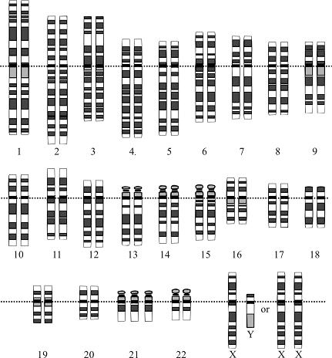

Treating Genetic Disorders
The symptoms of genetic disorders can sometimes be treated, but cures for genetic disorders are still in the early stages of development. One potential cure that has already been used with some success is gene therapy. This involves inserting normal genes into cells with mutant genes. At this point, gene technology is in its early stages of development and not widely used in medicine.

III. Biotechnology

Biotechnology is the use of technology to change the genetic makeup of living things for human purposes. Generally, the purpose of biotechnology is to create organisms that are useful to humans or to cure genetic disorders. For example, biotechnology may be used to create crops that resist insect pests or yield more food, or to create new treatments for human diseases. Biotechnology uses a variety of techniques to achieve its aims. A few important aspects of biotechnology are cloning and genetically modified organisms.

Genetically Modified Organims
A Genetically Modified Organism (GMO) has its DNA altered by modern science, often having DNA from two different species spliced together. While the idea of taking some DNA from one organism and inserting it into another may sound like science fiction, the majority of corn and soybeans grown in the US are genetically modified, commonly containing genes from bacteria. The United States is home to far more genetically modified crops than anywhere else in the world. In 2009, 85 percent of the country's corn, 88 percent of its cotton and 91 percent of its soybeans were cultivated from seeds genetically modified to resist plant pests and certain herbicides used to control weeds.

Applications of Biotechnology
Methods of biotechnology can be used for many practical purposes. They are used widely in both medicine and agriculture. In addition to gene therapy for genetic disorders, biotechnology can be used to transform bacteria so they are able to make human proteins. Figure 4 shows how this is done. The DNA that codes for the important protein cytokine is removed from a human cell and combined with some DNA from a bacterium. When the new piece of DNA is taken in by the bacterium, the protein can produce human cytokines. Proteins made by the bacteria are injected into people who cannot produce them because of mutations.

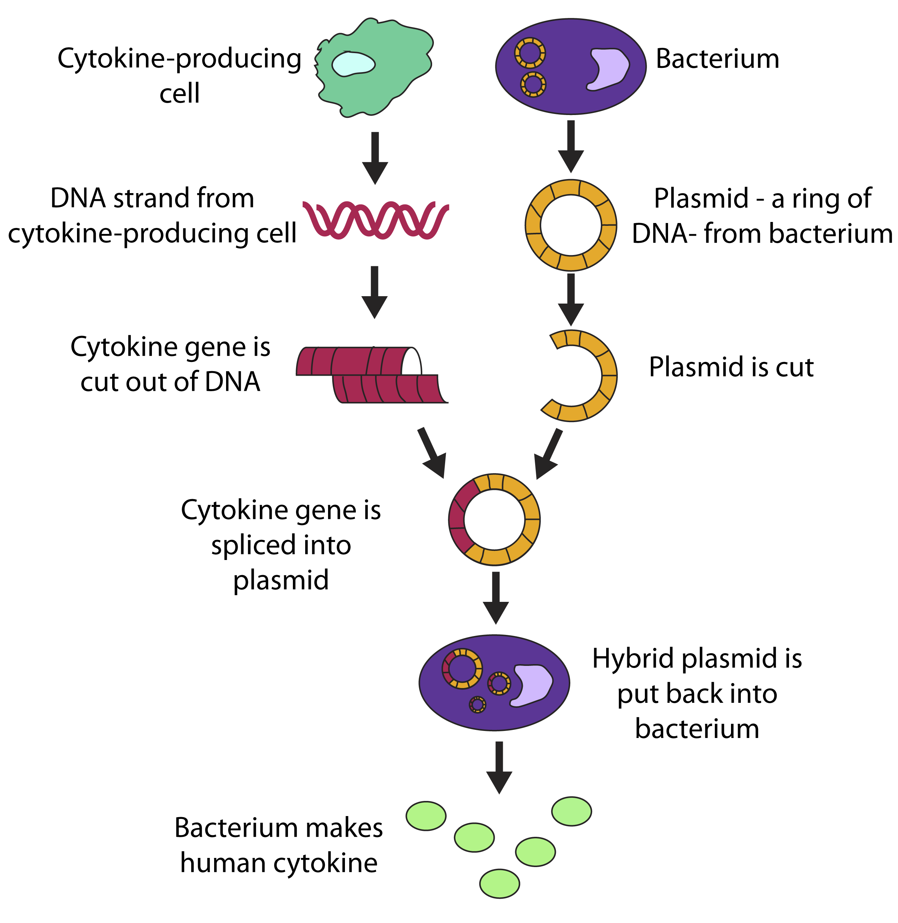
Figure 4. Genetically Engineering Bacteria to Produce a Human Protein. Bacteria can be genetically engineered to produce a human protein, such as a cytokine. A cytokine is a small protein that helps fight infections.

Insulin was the first human protein to be produced in this way. Insulin helps cells take up glucose from the blood. People with type 1 diabetes have a mutation in the gene that normally codes for insulin. Without insulin, their blood glucose rises to harmfully high levels. At present, the only treatment for type 1 diabetes is the injection of insulin from outside sources. Until recently, there was no known way to make insulin outside the human body. The problem was solved by biotechnology. The human insulin gene was inserted into bacterial cells, which could then produce large quantities of human insulin.

Applications in Agriculture
Biotechnology has been used to create transgenic crops. Transgenic crops are genetically modified with new genes that code for traits useful to humans. The diagram in Figure 5 shows how a transgenic crop is created. This technique has been used to create plants that can withstand applications of RoundUp (an effective herbicide that kills most plants) and rice with high levels of vitamins.

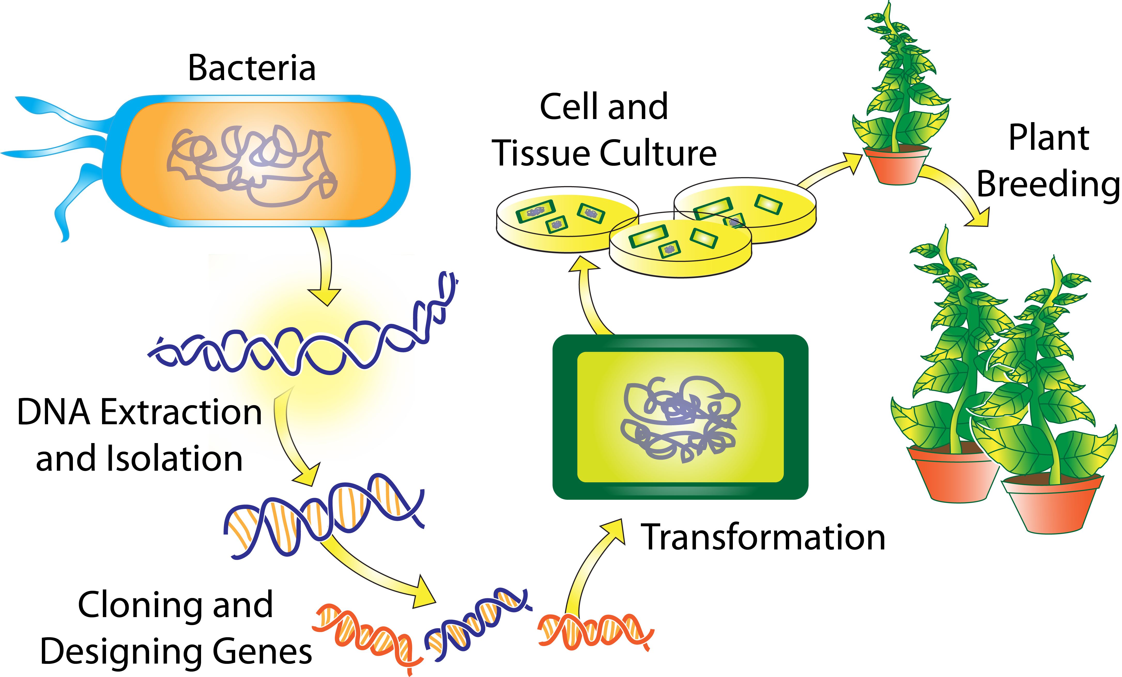

Figure 5. Creating a Transgenic Crop. A transgenic crop is genetically modified to be more useful to humans. Transgenic crops have been created with a variety of different traits, such as yielding more food, tasting better, surviving drought, and resisting insect pests.

You can learn more about how scientists create transgenic crops at
http://www.pbs.org/wgbh/harvest/engineer/transgen.html

Cloning
Cloning is the process of creating a genetically identical individual from an original cell. Cloning may hold potential benefits for the fields of medicine and agriculture. For instance, the same Scottish researchers who cloned Dolly have cloned other sheep that have been genetically modified to produce milk that contains a human protein essential for blood clotting. The hope is that someday this protein can be purified from the milk and given to humans whose blood does not clot properly. Another possible use of cloned animals is for testing new drugs and treatment strategies. The great advantage of using cloned animals for drug testing is that they are all genetically identical, which means their responses to the drugs should be uniform rather than variable as seen in animals with different genetic make-ups.

After consulting with many independent scientists and experts in cloning, the U.S. Food and Drug Administration (FDA) decided in January 2008 that meat and milk from cloned animals, such as cattle, pigs and goats, are as safe as those from non-cloned animals. The FDA action means that researchers are now free to using cloning methods to make copies of animals with desirable agricultural traits, such as high milk production or lean meat. However, because cloning is still very expensive, it will likely take many years until food products from cloned animals actually appear in supermarkets. Another application is to create clones to build populations of endangered, or possibly even extinct, species of animals. In 2001, researchers produced the first clone of an endangered species: a type of Asian ox known as a guar. Sadly, the baby guar, which had developed inside a surrogate cow mother, died just a few days after its birth. In 2003, another endangered type of ox, called the Banteg, was successfully cloned. Soon after, three African wildcats were cloned using frozen embryos as a source of DNA. Although some experts think cloning can save many species that would otherwise disappear, others argue that cloning produces a population of genetically identical individuals that lack the genetic variability necessary for species survival.

How are animals cloned?
The technique used to clone a whole, adult animal, such as sheep, is referred to as reproductive cloning.
In reproductive cloning, researchers remove a mature somatic cell, such as a skin cell or an udder cell, from an animal that they wish to copy. They then transfer the DNA of the donor animal's somatic cell into an egg cell that has had its own DNA-containing nucleus removed.

Researchers can add the DNA from the somatic cell to the egg by removing the DNA-containing nucleus of the somatic cell and inject it into the empty egg. The egg is allowed to develop into an early-stage embryo in the test-tube and then is implanted into the womb of an adult female animal. Ultimately, the adult female gives birth to an animal that has the same genetic make up as the animal that donated the somatic cell. This young animal is referred to as a clone. Reproductive cloning may require the use of a surrogate mother to allow development of the cloned embryo, as was the case for the most famous cloned organism, Dolly the sheep.

Stem Cells
Stem cells have the remarkable potential to develop into many different cell types in the body during early life and growth. In addition, in many tissues they serve as a sort of internal repair system, dividing essentially without limit to replenish other cells as long as the person or animal is still alive. When a stem cell divides, each new cell has the potential either to remain a stem cell or become another type of cell with a more specialized function, such as a muscle cell, a red blood cell, or a brain cell.

Stem cells are distinguished from other cell types by two important characteristics. First, they are unspecialized cells capable of renewing themselves through cell division, sometimes after long periods of inactivity. Second, under certain conditions, they can be induced to become tissue- or organ-specific cells with special functions. In some organs, such as the gut and bone marrow, stem cells regularly divide to repair and replace worn out or damaged tissues. In other organs, however, such as the pancreas and the heart, stem cells only divide under special conditions.

While stems cell are promising, they are also controversial. Many stem cells are known as human embryonic stem cells. The embryos used in these studies were created for reproductive purposes through in vitro fertilization procedures. When they were no longer needed for that purpose, they were donated for research with the informed consent of the donor.

Laboratory studies of stem cells enable scientists to learn about the cells’ essential properties and what makes them different from specialized cell types. Scientists are already using stem cells in the laboratory to screen new drugs and to develop model systems to study normal growth and identify the causes of birth defects. Research on stem cells continues to advance knowledge about how an organism develops from a single cell and how healthy cells replace damaged cells in adult organisms. Stem cell research is one of the most fascinating areas of contemporary biology, but, as with many expanding fields of scientific inquiry, research on stem cells raises scientific questions as rapidly as it generates new discoveries.

IV. Ethical, Legal, and Social Issues

Controversy and Biotechnology
The use of biotechnology has raised a number of ethical, legal, and social issues. Here are just a few:

- Who owns genetically modified organisms such as bacteria? Can such organisms be patented like inventions?
- Are genetically modified foods safe to eat? Might they have unknown harmful effects on the people who consume them?
- Are genetically engineered crops safe for the environment? Might they harm other organisms or even entire ecosystems?
- Who controls a person’s genetic information? What safeguards ensure that the information is kept private? How far should we go to ensure that children are free of mutations? Should a pregnancy be ended if the fetus has a mutation for a serious genetic disorder?

Addressing such issues is beyond the scope of this chapter. The following examples illustrate how complex the issues may be:
Dealing with Genetic Infomation
While the task of sorting through large volumes of genomic data remains a central challenge in modern biology and medicine, one of the knottiest dilemmas to emerge from this research is a social and ethical one. That is, how should people make use of information about their own genes? Because genetic information is both powerful and incredibly personal, there are deep societal concerns regarding its use. These concerns include the potential for discrimination on the basis of a person's risk of disease or susceptibility to toxicity from an environmental chemical.

Some laws are already in place to protect individuals from the misuse of their genetic information. When you visit a new doctor, nurse practitioner, or dentist, you'll be asked to read and sign a form that outlines your medical privacy rights under the Health Insurance Portability and Accountability Act, or HIPAA. This law protects your genetic and other personal health information from being used or shared without your knowledge.

Another law, the Genetic Information Nondiscrimination Act, or GINA, prohibits discrimination in health coverage and employment based on genetic information.

It's important to realize that, in most cases, genetic information cannot offer definitive proof that a disease will occur. But if you have a very strong family history of breast cancer, for example, there may be a faulty gene in your family that increases your risk of getting the disease. Doctors can now test for two known gene variants associated with inherited forms of breast cancer, BRCA1 and BRCA2. If you carry either of these gene variants, your lifetime risk of getting breast cancer is significantly higher than it would be for someone without either variant. But some people who have BRCA gene variants never get breast cancer.

Only about 5 percent of all breast cancer can be traced to a known, inherited gene variant. Since so many breast cancers are not linked to BRCA1 or BRCA2, genetic testing for these variants is irrelevant for the vast majority of people who do not have a family history of breast cancer. But let's say you do have a relative who tested positive for BRCA1 or 2. Should you get tested, too? A difficult question, for sure, but consider this: Knowing about this risk ahead of time might save your life. For example, you might want to begin getting mammogram's or other screening tests at an early age. If cancer is found very early, it is usually more treatable, and the odds for a cure are much higher.

Currently, diagnostic laboratories across the United States offer genetic tests for almost 2,000 disorders. Some of these tests detect problems with entire chromosomes, not just individual genes. Perhaps the most well-known example of a chromosome problem is Down syndrome, in which cells have an extra copy of chromosome 21. Most genetic diseases aren't caused by a chromosome abnormality, or even by one gene variant. Cystic fibrosis, for example, is due to a faulty gene, but more than 30 different variants of this gene can cause the disease, and those are just the ones researchers know about!

Scientists are developing genetic tests that will help doctors diagnose and treat diseases. One thing you might consider is whether you could do something with what you learn from a genetic test. You've already read about what you could do if you discovered that you were at high risk for developing breast cancer. But what about a condition that shows up in middle-aged or older people—or one for which there is currently no cure? As a teen or young adult, would you want to know that you'd get a serious, perhaps incurable, disease later in life? Patients and doctors face these tough issues every day. Even years from now, when researchers know more about the molecular roots of disease, genetic tests will rarely provide easy answers. In most cases, they won't even provide "yes" or "no" answers. Rather, much like a cholesterol test, they will predict whether a person's risk of getting a disease is relatively high, low or somewhere in between. This is because many factors besides genes, including lifestyle choices such as diet and exercise, also play a role in determining your health.

What are two societal issues surrounding genetic testing?

Explain the advantages of HIPAA and GINA.

Good Advice
Since the story of genes and health is so complicated and is likely to stay that way for a while, it is very important to consider genetic information in context. Health care professionals known as genetic counselors can be a big help to people who are thinking about getting a genetic test. As a profession, genetic counseling has been around since the mid-1900s. However, only a few specialty clinics offered counseling at that time. Now, genetic counseling is much more widely available. Today's genetic counselors have gone through a rigorous training process in which they earn a master's degree and learn genetics, medicine, laboratory procedures, counseling, social work and ethics. Genetic counselors do their work in many different settings, including hospitals, private clinics, government agencies and university laboratories.

Controversies in Agriculuture
A strain of corn has been created with a gene that encodes a natural pesticide. When insects such as cutworm eat these plants, they die due to effect of a protein produced by the plant. On the positive side, the transgenic corn is not eaten by insects, so there is more corn for people to eat. The corn also doesn’t need to be sprayed with chemical pesticides, which can harm people and other living things. On the negative side, the transgenic corn has been shown to cross-pollinate nearby milkweed plants. Offspring of the cross-pollinated milkweed plants may be toxic to monarch butterfly caterpillars that depend on them for food. Scientists are concerned that this may threaten the monarch populations as well as other species that normally eat monarchs. Perhaps we may create superweeds, weeds not commonly eaten by insects.

As this example shows, the pros of biotechnology may be obvious, but the cons may not be known until it is too late. Unforeseen harm may be done to people, other species, and entire ecosystems. No doubt the ethical, legal, and social issues raised by biotechnology will be debated for decades to come.

Many believe that agricultural biotechnology is an important driver for improving world health. They say that genetic modifications may be the only hope for pest-ravaged crops, such as bananas, that are essential to the economies of poor countries. The creation of edible plants that contain medicine, serve as a form of vaccination or deliver extra nutrients—such as the recently developed rice that makes vitamin A—could also contribute in major ways to global health.
But opposition from farmers and consumers within and outside the United States has clouded agricultural biotechnology's future. Some object to the development of plants that are naturally resistant to herbicides, partly out of concern that the trait might jump to weeds, making them impossible to destroy.

Environmental advocacy groups worry that genetically modified plants may impact the future biodiversity of our planet by harming beneficial insects and possibly other organisms. However, the U.S. Environmental Protection Agency has stated that there is no evidence to date that indicates that biotech crops have any adverse effects on non-targeted wildlife, plants or beneficial insects.

Of course, careful field tests of newly created, genetically modified plants and animals are essential to be sure that they cause no harm to other organisms or to the environment

Why might a crop that is resistant to an insect such as cutworm be a threat to other species?

Glossary

Amino acid A building block of proteins. There are 20 amino acids, each of which is coded for by three
adjacent nucleotides in a DNA sequence.
Autosomes (numbers 1–22). Autosomes are chromosomes that contain genes for characteristics that are
unrelated to sex. These chromosomes are the same in males and females.
Biotechnology The industrial use of living organisms or biological methods to create organisms that are
useful to humans or to cure genetic disorders derived through basic research.
Chromosomal Disorders: Disorder causes by an abnormal number of chromosomes.
Chromosome A cellular structure containing genes. Chromosomes are composed of DNA and proteins.
Cloning: In genetics, the process of making many copies of a gene or a whole organism.
Diploid: Having two copies of each chromosome.
DNA: Abbreviation for deoxyribonucleic acid.
Enzyme: A substance (often a protein) that speeds up, or catalyzes, a chemical reaction without being
permanently altered or consumed.
Eukaryote: An organism whose cells have a membrane-bound nucleus.
Gene: A segment of a DNA molecule that contains information for making a protein or, sometimes, an
RNA molecule.
Gene Expression: The process by which genes are first converted to messenger RNA and then to proteins.
Genetics: The scientific study of genes and heredity—of how particular qualities or traits are transmitted
from parents to offspring.
Genetic Counselors: Medical professions who advise patients considering a genetic test.
Genetically Modified Organism (GMO): has its DNA altered by modern science, often having DNA from
two different species spliced together
Genome: All of an organism's genetic material.
Haploid Having one copy of each chromosome, as in a sperm or egg.
Human Genome Project: International project that includes scientists from around the world. It began in
1990, and by 2003, scientists had sequenced all 3 billion base pairs of human DNA.
Karyotype: A picture of an individuals paired chromosomes.
Meiosis: The type of cell division that creates egg and sperm cells.
Mutation: A change in a DNA sequence.
Nondisjunction:. This is the failure of homologous chromosomes to separate during meiosis.
Nucleotide: A building block of DNA or RNA. It includes one base, one phosphate molecule and one
sugar molecule (deoxyribose in DNA, ribose in RNA).
Nucleus:The structure in the eukaryotic cell containing most of its genetic material.
Protein: A molecule consisting of subunits called amino acids. Proteins are the cell's main building
materials and do most of a cell's work.
Recombinant DNA: Hybrid DNA produced in the laboratory by joining pieces of DNA from different
sources.
Ribosome: The cell structure in which proteins are manufactured.
Sex chromosomes: X and Y. Females have two X chromosomes, and males have one X and one Y
chromosome
Somatic cell: Cells other than sex chromosomes; chromosomes that are the same between males and
females (in humans, chromosome #s 1 – 22).
Stem Cell: A cell that can develop into many different cell types in the body.
Transgenic crops are genetically modified with new genes that code for traits useful to humans.

Sources

Text: ck12 Biology FlexBook (August 23, 2010)

Dealing with Genetic Information section adapted from National Institute of Health, http://publications.nigms.nih.gov/order/pubdescriptions/newgenetics.html)

Stem Cells and Cloning section adapted from http://stemcells.nih.gov/info/basics/basics1.asp

