Evolution Unit Flexbook – Brandon Valley High School (Lovrien)

I. The Theory of Evolution by Natural Selection

The Englishman Charles Darwin is one of the most famous scientists who ever lived. His place in the history of science is well deserved. Darwin’s theory of evolution is the unifying theme of modern biology.

Darwin’s theory of evolution actually contains two major ideas:
One idea is that evolution occurs. In other words, organisms change over time. Life on Earth has changed as descendants diverged from common ancestors in the past. The other idea is that evolution occurs by natural selection. Natural selection is the process in which living things with beneficial traits produce more offspring than others do. Natural selection is the mechanism by which life on earth evolves. This results in changes in the traits of living things over time.

In Darwin’s day, most people believed that all species were created at the same time and remained unchanged thereafter. Many also believed that Earth was only 6,000 years old. Therefore, Darwin’s ideas revolutionized biology. How did Darwin come up with these important ideas? It all started when he went on a voyage.

The Voyage of the Beagle
In 1831, when Darwin was just 22 years old, he set sail on a scientific expedition on a ship called the HMS Beagle. He was the naturalist on the voyage. As a naturalist, it was his job to observe and collect specimens of plants, animals, rocks, and fossils wherever the expedition went ashore. The route the ship took and the stops they made are shown in Figure 1. Darwin was fascinated by nature, so he loved his job on the Beagle. He spent more than 3 years of the 5-year trip exploring nature on distant continents and islands.
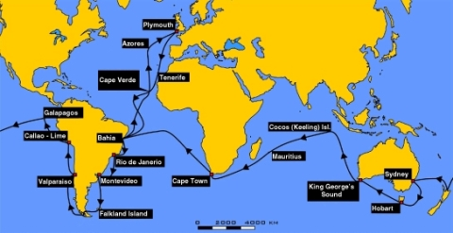

Darwin’s Observations
Figure 1. Route traveled by the HMS Beagle.
During the long voyage, Darwin made many observations that helped him form his theory of evolution. For example: He visited tropical rainforests and other new habitats where he saw many plants and animals he had never seen before. This impressed him with the great diversity of life. He experienced an earthquake that lifted the ocean floor 2.7 meters (9 feet) above sea level. He also found rocks containing fossil sea shells in mountains high above sea level. These observations suggested that continents and oceans had changed dramatically over time and continue to change in dramatic ways. He visited rock ledges that had clearly once been beaches that had gradually built up over time. This suggested that slow, steady processes also change Earth’s surface. He dug up fossils of gigantic extinct mammals, such as the ground sloth. This was hard evidence that organisms looked very different in the past. It suggested that living things—like Earth’s surface—change over time.

The Galápagos Islands
Darwin’s most important observations were made on the Galápagos Islands (see map in Figure below). This is a group of 16 small volcanic islands 966 kilometers (600 miles) off the west coast of South America.

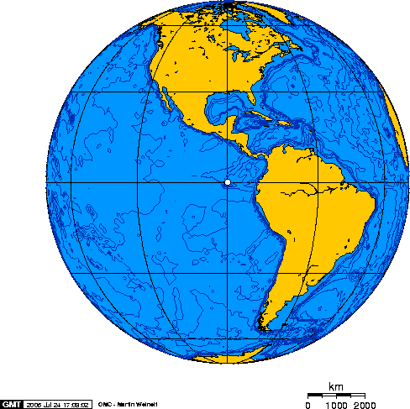

Individual Galápagos islands differ from one another in important ways. Some are rocky and dry. Others have better soil and more rainfall. Darwin noticed that the plants and animals on the different islands also differed. For example, the giant tortoises on one island had saddle-shaped shells, while those on another island had dome-shaped shells. People who lived on the islands could even tell the island a turtle came from by its shell. This started Darwin thinking about the origin of species. He wondered how each island came to have its own type of tortoise.

Influences on Darwin
Science, like evolution, always builds on the past. Darwin didn’t develop his theory completely on his own. He was influenced by the ideas of earlier thinkers.

Jean Baptiste Lamarck (1744–1829) was an important French naturalist. He was one of the first scientists to propose that species change over time. However, Lamarck was wrong about how species change. His idea of the inheritance of acquired characteristics is incorrect. Traits an organism develops during its own life time cannot be passed on to offspring, as Lamarck believed.

Charles Lyell (1797–1875) was a well-known English geologist. Darwin took his book, Principles of Geology, with him on the Beagle. In the book, Lyell argued that gradual geological processes have gradually shaped Earth’s surface. From this, Lyell inferred that Earth must be far older than most people believed. Lyell interpreted the historical geography of Earth as being shaped by slow-acting gradual forces, rather than a few catastrophic events.

Thomas Malthus (1766–1834) was an English economist. He wrote an essay titled On Population. In the essay, Malthus argued that human populations grow faster than the resources they depend on. When populations become too large, famine and disease break out. In the end, this keeps populations in check by killing off the weakest members. Malthus argued populations often grow exponentially, taxing the ability of resources to keep up with the growing demand for food and other essentials.

Artificial Selection
These weren’t the only influences on Darwin. He was also aware that humans could breed plants and animals to have useful traits. By selecting which animals were allowed to reproduce, they could change an organism’s traits. Pigeons are good examples. Darwin called this type of change in organisms artificial selection. He used the word artificial to distinguish it from natural selection.

Wallace’s Theory
Did you ever hear the saying that “great minds think alike?” It certainly applies to Charles Darwin and another English naturalist named Alfred Russel Wallace. Wallace lived at about the same time as Darwin. He also traveled to distant places to study nature. Wallace wasn’t as famous as Darwin. However, he developed basically the same theory of evolution. While working in distant lands, Wallace sent Darwin a paper he had written. In the paper, Wallace explained his evolutionary theory. This served to confirm what Darwin already thought.

Darwin’s Theory of Evolution by Natural Selection
Darwin spent many years thinking about the work of Lamarck, Lyell and Malthus, what he had seen on his voyage, and artificial selection. What did all this mean? How did it all fit together? It fits together in Darwin’s theory of evolution by natural selection. It’s easy to see how all of these influences helped shape Darwin’s ideas.

Evolution of Darwin’s Theory
It took Darwin years to form his theory of evolution by natural selection. His reasoning went like this:
Like Lamarck, Darwin assumed that species can change over time. The fossils he found helped convince him of that.
From Lyell, Darwin saw that Earth and its life were very old. Thus, there had been enough time for evolution to produce the great diversity of life Darwin had observed.
From Malthus, Darwin knew that populations could grow faster than their resources. This “overproduction of offspring” led to a “struggle for existence,” in Darwin’s words.
From artificial selection, Darwin knew that some offspring have chance variations that can be inherited. In nature, offspring with certain variations might be more likely to survive the “struggle for existence” and reproduce. If so, they would pass their favorable variations to their offspring.
Darwin coined the term fitness to refer to an organism’s relative ability to survive and produce fertile offspring. Nature selects the variations that are most useful. Therefore, he called this type of selection natural selection.
Darwin knew artificial selection could change domestic species over time. He inferred that natural selection could also change species over time. In fact, he thought that if a species changed enough, it might evolve into a new species.

Natural selection can be summed up in three parts:
- Within a species, there exists individual variation. Some of the individual characteristics can be passed on to offspring.
- Organisms produce more offspring than can survive.
- Those individuals with adaptations best suited to their environment will survive and pass on their traits to the next generation.

Wallace’s paper confirmed Darwin’s ideas and pushed him to publish his book, On the Origin of Species. Published in 1859, this book changed science forever. It clearly spelled out Darwin’s theory of evolution by natural selection and provided convincing arguments and evidence to support it.

II. Microevolution and the Genetics of Populations

Darwin knew that heritable variations are needed for evolution to occur. However, he knew nothing about Mendel’s laws of genetics. Mendel’s laws were rediscovered in the early 1900s. Only then could scientists fully understand the process of evolution.

The Scale of Evolution
We now know that variations of traits are heritable. These variations are determined by different alleles. We also know that evolution is due to a change in alleles over time. How long a time? That depends on the scale of evolution.
Microevolution occurs over a relatively short period of time within a population or species. Macroevolution occurs over geologic time and results in the formation of a new species. The fossil record reflects this level of evolution. It results from microevolution taking place over many generations.

Genes in Populations
Individuals do not evolve. Their genes do not change over time. The unit of evolution is the population. A population consists of organisms of the same species that live in the same area. In terms of evolution, the population is assumed to be a relatively closed group. This means that most mating takes place within the population. The science that focuses on evolution within populations is population genetics. It is a combination of evolutionary theory and Mendelian genetics.

Gene Pool
The genetic makeup of an individual is the individual’s genotype. A population consists of many genotypes. Altogether, they make up the population’s gene pool. The gene pool consists of all the genes of all the members of the population. For each gene, the gene pool includes all the different alleles for the gene that exist in the population. For a given gene, the population is characterized by the frequency of the different alleles in the gene pool.

Forces of Evolution

Mutation
Mutation creates new genetic variation in a gene pool. It is how all new alleles first arise. In sexually reproducing species, the mutations that matter for evolution are those that occur in gametes. Only these mutations can be passed to offspring. For any given gene, the chance of a mutation occurring in a given gamete is very low. Thus, mutations alone do not have much effect on allele frequencies. However, mutations provide the genetic variation needed for other forces of evolution to act.

Natural Selection
Natural selection occurs when there are differences in fitness among members of a population. As a result, some individuals pass more genes to the next generation. This causes allele frequencies to change. The example of sickle-cell anemia is described in Figure below and Table below. It shows how natural selection can keep a harmful allele in a gene pool. You can also watch a video about natural selection and sickle-cell anemia at this link: http://www.pbs.org/wgbh/evolution/library/01/2/l_012_02.html.

Sickle Cell and Natural Selection.

Genotype Phenotype Fitness
AA 100% normal hemoglobin Somewhat reduced fitness because
of no resistance to malaria

AS Enough normal hemoglobin Highest fitness because
to prevent sickle-cell anemia of resistance to malaria

SS 100% abnormal hemoglobin, Greatly reduced fitness because
causing sickle-cell anemia of sickle-cell anemia

Here’s how natural selection can keep a harmful allele in a gene pool:
The allele (S) for sickle-cell anemia is a harmful autosomal recessive. It is caused by a mutation in the normal allele (A) for hemoglobin (a protein on red blood cells). Malaria is a deadly tropical disease. It is common in many African populations. Heterozygotes (AS) with the sickle-cell allele are resistant to malaria. Therefore, they are more likely to survive and reproduce. This keeps the S allele in the gene pool.

The sickle-cell example shows that fitness depends on phenotypes. It also shows that fitness may depend on the environment. What do you think might happen if malaria was eliminated in an African population with a relatively high frequency of the S allele? How might the fitness of the different genotypes change? How might this affect the frequency of the S allele? Sickle-cell trait is controlled by a single gene.

III. Macroevolution and the Origin of Species

Macroevolution is evolution over geologic time above the level of the species. One of the main topics in macroevolution is how new species arise. The process by which a new species evolves is called speciation.

Origin of Species
To understand how a new species forms, it’s important to review what a species is. A species is a group of organisms that can breed and produce fertile offspring together in nature. For a new species to arise, some members of a species must become reproductively isolated from the rest of the species. This means they can no longer interbreed with other members of the species. How does this happen? Usually they become geographically isolated first.

Allopatric Speciation
Assume that some members of a species become geographically separated from the rest of the species. If they remain separated long enough, they may evolve genetic differences. If the differences prevent them from interbreeding with members of the original species, they have evolved into a new species. Speciation that occurs in this way is called allopatric speciation.

Timing of Macroevolution
Is evolution slow and steady? Or does it occur in fits and starts? It may depend on what else is going on, such as changes in climate and geologic conditions.
When geologic and climatic conditions are stable, evolution may occur gradually. This is how Darwin thought evolution occurred. This model of the timing of evolution is called gradualism.

When geologic and climatic conditions are changing, evolution may occur more quickly. Thus, long periods of little change may be interrupted by bursts of rapid change. This model of the timing of evolution is called punctuated equilibrium. It is better supported by the fossil record than is gradualism.

IV. Evidence for Evolution

In his book On the Origin of Species, Darwin included a lot of evidence to show that evolution had taken place. He also made logical arguments to support his theory that evolution occurs by natural selection. Since Darwin’s time, much more evidence has been gathered. The evidence includes a huge number of fossils. It also includes more detailed knowledge of living things, right down to their DNA.

Fossil Evidence
Fossils are a window into the past. They provide clear evidence that evolution has occurred. Scientists who find and study fossils are called paleontologists. How do they use fossils to understand the past? Consider the example of the horse, shown in Figure 3. The fossil record shows how the horse evolved.

Figure 3. Evolution of the Horse. The fossil record reveals how horses evolved.
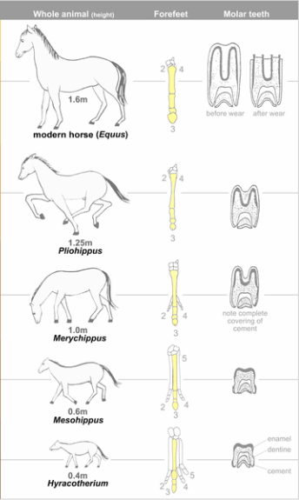
The oldest horse fossils show what the earliest horses were like. They were about the size of a fox, and they had four long toes. Other evidence shows they lived in wooded marshlands, where they probably ate soft leaves. Through time, the climate became drier, and grasslands slowly replaced the marshes. Later fossils show that horses changed as well.

They became taller, which would help them see predators while they fed in tall grasses.
They evolved a single large toe that eventually became a hoof. This would help them run swiftly and escape predators.
Their molars (back teeth) became longer and covered with enamel. This would allow them to grind tough grasses and grass seeds without wearing out their teeth.

Similar fossil evidence demonstrates the evolution of the whale, moving from the land into the sea. An animation of this process can be viewed at http://collections.tepapa.govt.nz/exhibitions/whales/Segment.aspx?irn=161.

Evidence from Living Species
Just as Darwin did, today’s scientists study living species to learn about evolution. They compare the anatomy, embryos, and DNA of modern organisms to understand how they evolved.

Comparative Anatomy
Comparative anatomy is the study of the similarities and differences in the structures of different species. Similar body parts may be homologies or analogies. Both provide evidence for evolution.
Homologous structures are structures that are similar in related organisms because they were inherited from a common ancestor. These structures may or may not have the same function in the descendants. Figure 4 shows the hands of several different mammals. They all have the same basic pattern of bones. They inherited this pattern from a common ancestor. However, their forelimbs now have different functions.

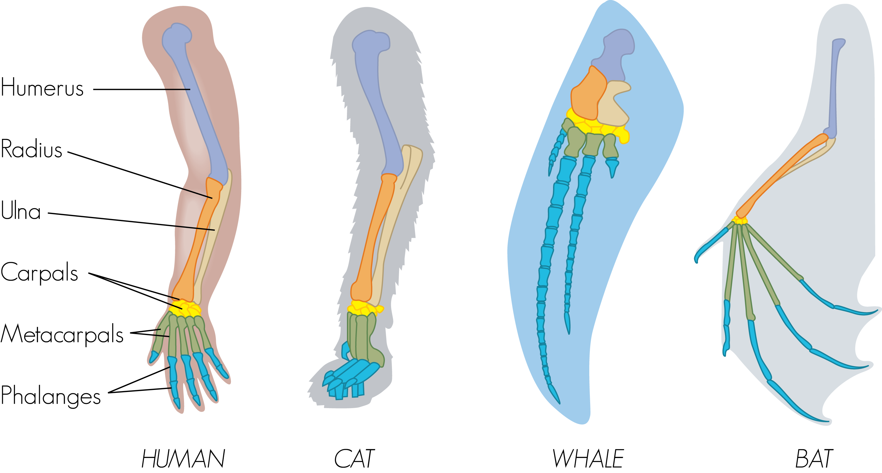

Figure 4. Hands of Different Mammals. The forelimbs of all mammals have the same basic bone structure.

Analogous structures are structures that are similar in unrelated organisms. The structures are similar because they evolved to do the same job, not because they were inherited from a common ancestor. For example, the wings of bats and birds, shown in Figure 5, look similar on the outside. They also have the same function. However, wings evolved independently in the two groups of animals. This is apparent when you compare the pattern of bones inside the wings.

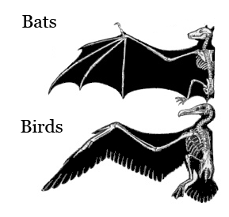
Figure 5. Wings of Bats and Birds.

Wings of bats and birds serve the same function. Look closely at the bones inside the wings. The differences show they developed from different ancestors.

Comparative Embryology
Comparative embryology is the study of the similarities and differences in the embryos of different species. Similarities in embryos are evidence of common ancestry. All vertebrate embryos, for example, have gill slits and tails, as shown in Figure 6. All of the animals in the figure, except for fish, lose their gill slits by adulthood. Some of them also lose their tail. In humans, the tail is reduced to the tail bone. Thus, similarities organisms share as embryos may be gone by adulthood.
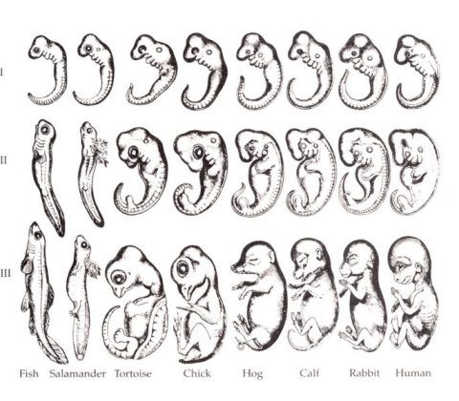
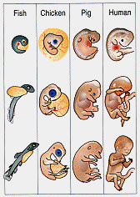

Figure 6. Vertebrate Embryos. Embryos of different vertebrates look much more similar than the adult organisms do. (Note: The numbers I to III refer to the sequence of stages the embryos go through.)

The figure on the left is based upon the drawings of Haekel (1897) Although he admitted during his lifetime that he altered the drawings of early embryos to exaggerate their similarities, the drawings have continued to be used for over 100 years. To the right is a more accurate representation Dr. Kenneth Miller now includes in biology textbooks he authors. Science is based on observable, testable observations. What do you think of the similarities between vertebrate embryos? Watch:
http://www.pbs.org/wgbh/nova/odyssey/clips/

Vestigial Structures
Structures like the human tail bone are called vestigial structures. Evolution has reduced their size because the structures are no longer used. The human appendix is another example of a vestigial structure. It is a tiny remnant of a once-larger organ. In a distant ancestor, it was needed to digest food. It serves no purpose in humans today. Why do you think structures that are no longer used shrink in size? Why might a full-sized, unused structure reduce an organism’s fitness?

Comparing DNA
Darwin could compare only the anatomy and embryos of living things. Today, scientists can compare their DNA. Similar DNA sequences are the strongest evidence for evolution from a common ancestor.

Evidence from Biogeography
Biogeography is the study of how and why plants and animals live where they do. It provides more evidence for evolution.

Island Biogeography
The biogeography of islands yields some of the best evidence for evolution. Consider the birds called finches that Darwin studied on the Galápagos Islands. All of the finches probably descended from one bird that arrived on the islands from South America. Until the first bird arrived, there had never been birds on the islands. The first bird was a seed eater. It evolved into many finch species. Each species was adapted for a different type of food. This is an example of adaptive radiation. This is the process by which a single species evolves into many new species to fill available niches.

Eyewitness to Evolution
In the 1970s, biologists Peter and Rosemary Grant went to the Galápagos Islands. They wanted to re-study Darwin’s finches. They spent more than 30 years on the project. Their efforts paid off. They were able to observe evolution by natural selection actually taking place. While the Grants were on the Galápagos, a drought occurred. As a result, fewer seeds were available for finches to eat. Birds with smaller beaks could crack open and eat only the smaller seeds. Birds with bigger beaks could crack and eat seeds of all sizes. As a result, many of the small-beaked birds died in the drought. Birds with bigger beaks survived and reproduced. Within 2 years, the average beak size in the finch population increased. Evolution by natural selection had occurred.

