Unit 2: Chemistry of Life
“You can be a chemist without being a biologist,
but you can’t be a biologist without being a chemist”

I. Matter pages 2 -4

II. Chemical Reactions and Energy pages 5 – 6

III. Water pages 7 – 9

IV. Organic Compounds pages 10 – 12

V. Enzymes pages 13 - 15

Vocabulary page 16

South Dakota Science Standards

9-12.P.1.1. Students are able to use the Periodic Table to determine the atomic structure of elements, valence number, family relationships, and regions (metals, nonmetals, and metalloids).
9-12.P.1.2. Students are able to describe ways that atoms combine.
- Compare the roles of electrons in covalent, ionic, and metallic bonding.
- Discuss the special nature of carbon covalent bonds.
9-12.P.1.3. Students are able to predict whether reactions will speed up or slow down as conditions change.
Examples: temperature, concentration, surface area, and catalysts
9-12.P.1.4. Students are able to balance chemical equations by applying the Law of Conservation of Matter.
- Trace number of particles in diagrams and pictures of balanced equations.
9-12.P.1.5. Students are able to distinguish among chemical, physical, and nuclear changes.
9-12.L.1.1. Students are able to relate cellular functions and processes to specialized structures within cells
Role of enzymes

Prefix/Suffix | Definition
Photo- | Light
Mono- | One
Di- | Two
Poly- | Many
Hydr | Water

Key Vocabulary Terms

1. Enzyme
2. Catalyst:
3. Polar Molecule
4. Organic Molecule
5. Inorganic
6. Ionic Bond
7. Covalent Bond

I. Matter

Living things are made of matter. In fact, matter is the “stuff” of which all things are made. Anything that occupies space and has mass is known as matter. Matter, in turn, consists of chemical substances. A chemical substance may be an element or a chemical compound.

Elements
An element is a pure substance that cannot be broken down into different types of substances. Examples of elements include carbon, oxygen, hydrogen, and iron. Each element is made up of just one type of atom.
An atom is the smallest particle of an element that still characterizes the element. As shown in Figure 1, at the center of an atom is a nucleus. The nucleus contains positively charged particles called protons and electrically neutral particles called neutrons. Surrounding the nucleus is a much larger electron cloud consisting of negatively charged electrons. An atom is electrically neutral if it has the same number of protons as electrons. Each element has atoms with a characteristic number of protons. For example, all carbon atoms have six protons, and all oxygen atoms have eight protons.

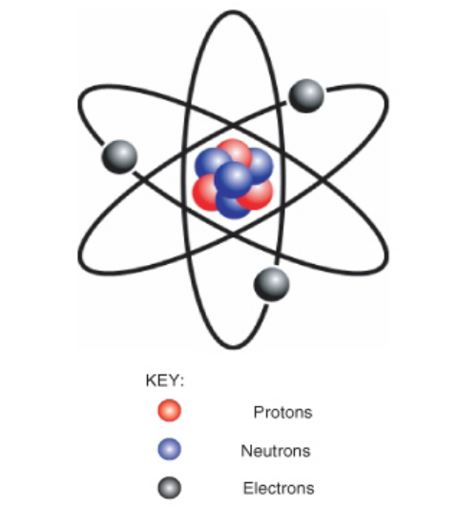

Figure 1: Model of an Atom. The protons and neutrons
of this atom make up its nucleus. Electrons surround the nucleus.

There are almost 120 known elements (see Periodic Table of the Elements). Each element is given a chemical symbol (O, oxygen; C, carbon) and an atomic number (the number of protons in the nucleus). For each element, the number of protons is constant; the number of electrons and neutrons can change, but a change in the number of protons results in a new element. If the number of protons and electrons do not match, the atom will have an electrical charge; such atoms are known as ions.

Periodic Table of the Element (as presented on South Dakota STEP Test)
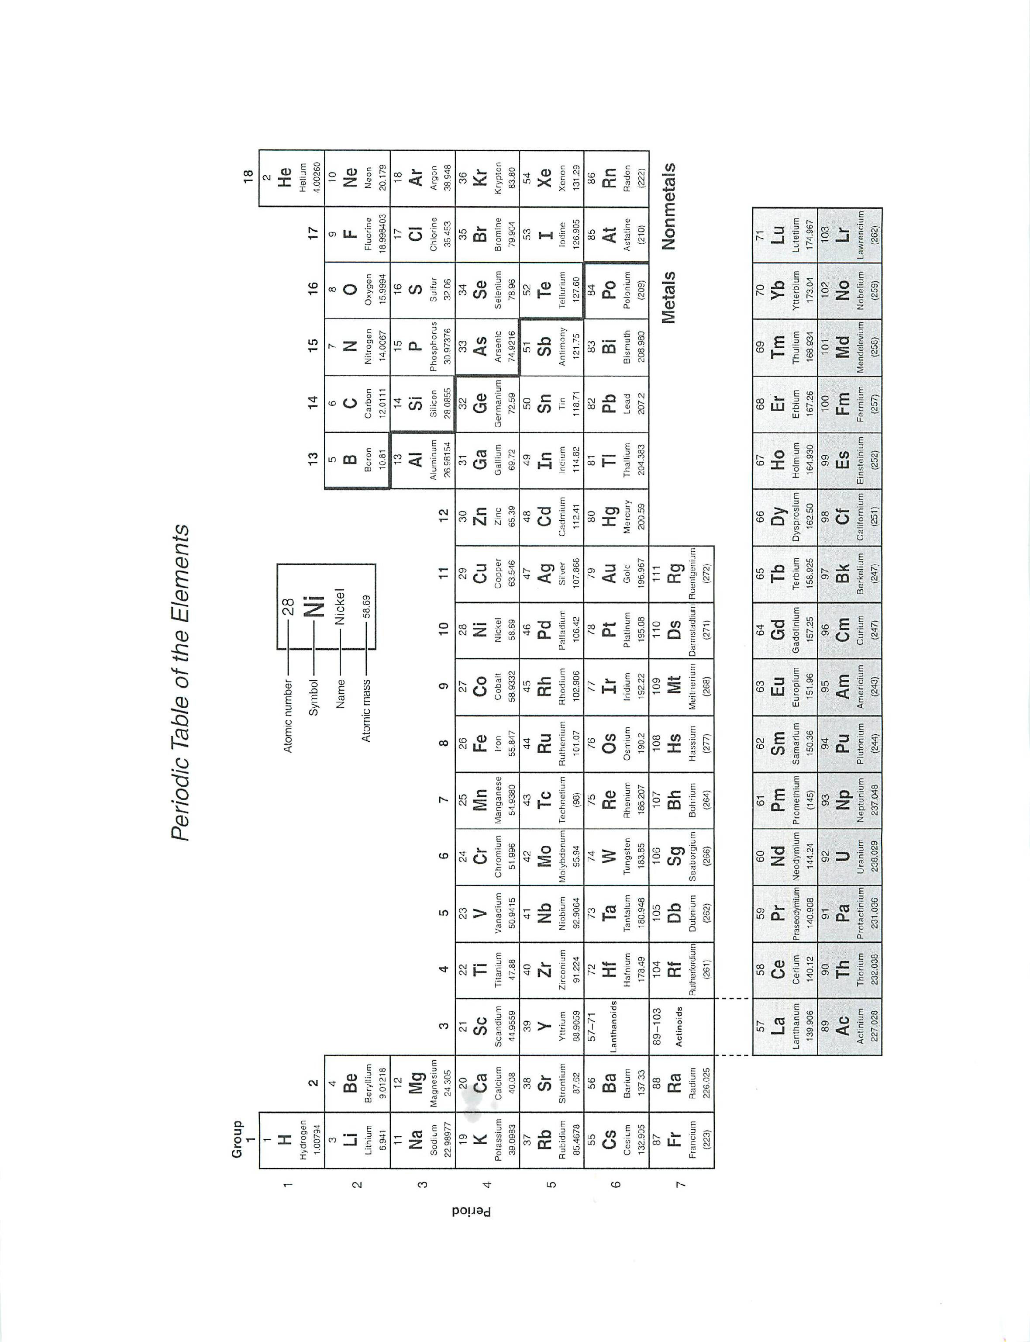

Chemical Compounds
A chemical compound is a new substance that forms when atoms of two or more elements react with one another. A chemical reaction is a process that changes some chemical substances into other chemical substances. A compound that results from a chemical reaction always has a unique and fixed chemical composition. The substances in the compound can be separated from one another only by another chemical reaction. In contrast, a mixture can be separated by physical means. A mixture of iron filings and sulfur can be separated by a magnet as iron is magnetic, thus this is a mixture.

The atoms of a compound are held together by chemical bonds. Chemical bonds form when atoms share electrons. There are different types of chemical bonds, and they vary in how strongly they hold together the atoms of a compound. Two of the strongest types of bonds are covalent and ionic bonds. Covalent bonds generally form between two nonmetallic atoms. Ionic bonds, in contrast, generally form between a metal and nonmetal. On the periodic table, notice the dark stairstep line starting at Boron. This line separates metals (most elements to the left) and nonmetals (most of the elements to the right). A notable exception is hydrogen, a nonmetal that is place at the upper left of the periodic table.

An example of a chemical compound is water. A water molecule forms when oxygen (O) and hydrogen (H) atoms react and are held together by covalent bonds. Like other compounds, water always has the same chemical composition: a 2:1 ratio of hydrogen atoms to oxygen atoms. This is expressed in the chemical formula H₂O. Figure 2 shows a model of a water molecule.

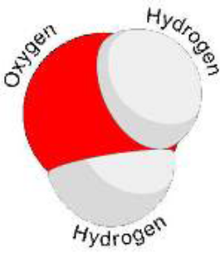

Figure 2: Model of a water molecule, showing the arrangement of hydrogen and oxygen atoms

When atoms are held together with covalent bonds, they form molecules. All molecules of the same chemical compound have the same composition. For example, all water molecules consist of two hydrogen atoms bound to one oxygen atom. The molecular formula, H₂0, indicates the number of atoms in each molecule. For water, the subscript “2” after the “H” indicates two hydrogen atoms while the lack of a number after the “O” indicates only one oxygen atom in each molecule.

Chemical bonds form when atoms share
(a) neutrons. (b) electrons. (c) protons. (d) molecules.

Which element is a nonmetal?
(a) iron (b) gold (c) copper (d) hydrogen

II. Chemical Reactions and Energy

Energy is a property of matter that is defined as the ability to do work. All living organisms need energy to grow and reproduce. However, energy can never be created or destroyed, it is always conserved. This is called the Law of Conservation of Energy. Therefore, organisms cannot create the energy they need. Instead, they must obtain energy from the environment. Organisms also cannot destroy or use up the energy they obtain, they can only change it from one form to another. Energy can take several different forms. Common forms of energy include light, chemical, and heat energy. Other common forms are kinetic and potential energy.

How Organisms Change Energy
In organisms, energy is always changing from one form to another. For example, plants obtain light energy from sunlight and change it to stored chemical energy in food molecules. Chemical energy is energy stored in bonds between atoms within food molecules. When other organisms eat and digest the food, they break the chemical bonds and release the chemical energy. About 90 percent of the energy they obtain from food is converted to heat energy that is given off to the environment.

Kinetic and Potential Energy
Energy also constantly changes back and forth between kinetic and potential energy. Kinetic energy is the energy of movement. For example, a ball falling through the air has kinetic energy because it is moving. Potential energy is the energy stored in an object due to its position. A ball held above the ground has potential energy; when it is dropped, it now has kinetic energy. Like the ball, every time you move you have kinetic energy — whether you jump or run or just blink your eyes. Can you think of situations in which you have potential energy? Obvious examples might include when you are standing on a diving board or at the top of a ski slope or bungee jump. What gives you potential energy in all of these situations? The answer is gravity.

In biology, what is the most important form of potential energy? Food. A calorie is a measure of how much potential energy is stored in food. Organisms are capable of starting with potential energy, such as sugar, and converting it into movement, heat and the numerous others forms of energy involved with biological processes.

Chemical Reactions
A chemical compound may be very different from the substances that combine to form it. For example, the element chlorine (Cl) is a poisonous gas, but when it combines with sodium (Na) to form sodium chloride (NaCl), it is no longer toxic. You may even eat it on your food. Sodium chloride is just table salt. What process changes a toxic chemical like chlorine into a much different substance like table salt?

A chemical reaction is a process that changes some chemical substances into other chemical substances. The substances that start a chemical reaction are called reactants. The substances that form as a result of a chemical reaction are called products. During the reaction, the reactants are used up to create the products. For example, during photosynthesis, carbon dioxide and water react (w/ energy provided by light) to produce sugar and oxygen. In this reaction, the reactants are carbon dioxide (CO₂) and water (H₂O), and the products are carbon dioxide (C₆H₁₂O₆) and oxygen (O₂).

Chemical Equations
A chemical reaction can be represented by a chemical equation. Using the same example from above, the process of photosythesis can be represented by the equation:

6 CO₂ + 6 H₂O → 6 O₂ + C₆H₁₂O₆

The arrow in a chemical equation separates the reactants from the products and shows the direction in which the reaction occurs. On each side of the arrow, a mixture of chemicals is indicated by the chemical symbols joined by a plus sign (+). The numbers preceding some of the chemical symbols (such as 6 O₂) indicate how many molecules of the chemicals are involved in the reaction. (If there is no number in front of a chemical symbol, it means that just one molecule is involved.) In the equation for photosynthesis, six molecules of carbon dioxide combine with six molecules of water. Each molecule of carbon dioxide (CO₂) consists of one carbon atom and two oxygen atoms.

In a chemical reaction, the quantity of each element does not change. There is the same amount of each element at the end of the reaction as there was at the beginning. This is reflected in the chemical equation for the reaction. The equation should be balanced. In a balanced equation, the same number of atoms of a given element appear on each side of the arrow. For example, in the equation above, there are six carbon atoms on each side of the arrow. The number of atoms must be the same on each side of the arrow due to the Law of Conservation of Matter, which states that in a chemical reaction matter is neither created nor destroyed.

Activation Energy
All need energy to get started. This energy is called activation energy. Activation energy is like the push you need to start moving down a slide. The push gives you enough energy to start moving. Once you start, you keep moving without being pushed again.

Why do reactions need energy to get started? In order for reactions to occur, three things must happen, and they all require energy:

• Reactant molecules must collide. To collide, they must move, so they need kinetic energy.

• Unless reactant molecules are positioned correctly, intermolecular forces may push them apart.
To overcome these forces and move together requires more energy.

• If reactant molecules collide and move together, there must be enough energy left for them to react.

Which object has kinetic energy?
(a) A tire on a parked car.
(b) A stone at the bottom of a pond.
(c) A leaf falling from a tree.
(d) A diver standing on a diving board.

How many molecules of oxygen are reactants in this chemical reaction?
CH₄ +2O₂ → CO₂ + H₂O
(a) zero (b) one (c) two (d) four
III. WATER

Water, like carbon, has a special role in biology because of its importance to organisms. In fact, water is essential to all known forms of life. The structure of water gives it unique properties that explain why water is so vital for life. Water is a common chemical substance on Earth. The term water generally refers to its liquid state. Water is a liquid over a wide range of standard temperatures and pressures. However, water can also occur as a solid (ice) or gas (water vapor).

Of all the water on Earth, about two percent is stored underground in spaces between rocks. A fraction of a percent exists in the air as water vapor, clouds, or precipitation. Another fraction of a percent occurs in the bodies of plants and animals. So where is most of Earth’s water? It’s on the surface of the planet. In fact, water covers about 70 percent of Earth’s surface. Of water on Earth’s surface, 97 percent is salt water, mainly in the ocean. Only 3 percent is freshwater. Most of the freshwater is frozen in glaciers and polar ice caps. The remaining freshwater occurs in rivers, lakes, and other freshwater features. Although clean freshwater is essential to human life, in many parts of the world it is in short supply. The amount of freshwater is not the issue. There is plenty of freshwater to go around, because water constantly recycles on Earth. However, freshwater is not necessarily located where it is needed, and clean freshwater is not always available.

Chemical Structure of Water
Each molecule of water consists of one atom of oxygen and two atoms of hydrogen, so it has the chemical formula H₂O. The arrangement of atoms in a water molecule, shown in Figure 3, explains many of water’s chemical properties. In each water molecule, the nucleus of the oxygen atom attracts electrons much more strongly than do the hydrogen nuclei. This results in a negative electrical charge near the oxygen atom (due to the “pull” of the negatively charged electrons toward the oxygen nucleus) and a positive electrical charge near the hydrogen atoms. A difference in electrical charge between different parts of a molecule is called polarity. A polar molecule is a molecule in which part of the molecule is positively charged and part of the molecule is negatively charged.

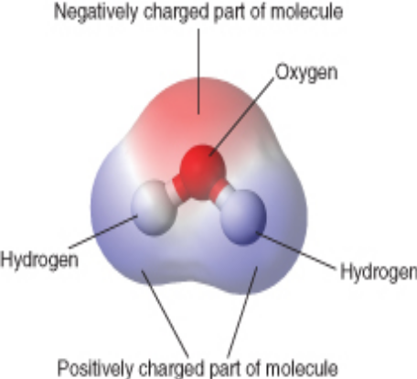
Figure 3: Water, A Polar Molecule: This model shows the arrangement of oxygen and hydrogen atoms in a water molecule. The nucleus of the oxygen atom attracts electrons more strongly than do the hydrogen nuclei. As a result, the middle part of the molecule near oxygen has a negative charge, and the other parts of the molecule have a positive charge. In essence, the electrons are “pulled” toward the nucleus of the oxygen atom and away from the hydrogen atom nuclei.

Opposite electrical charges attract one another other. Therefore, the positive part of one water molecule is attracted to the negative parts of other water molecules. Because of this attraction, bonds form between hydrogen and oxygen atoms of adjacent water molecules, as shown in Figure 4. This type of bond always involves a hydrogen atom, so it is called a hydrogen bond. Hydrogen bonds are bonds between molecules, and they are not as strong as bonds within molecules. Nonetheless, they help hold water molecules together.

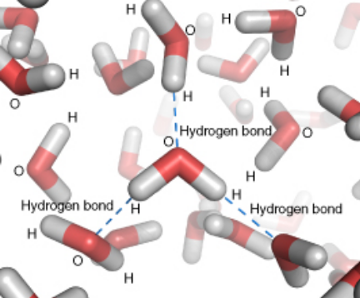

Figure 4: Hydrogen Bonding Between Water Molecules: Hydrogen bonds form between positively and negatively charged parts of water molecules. The bonds hold the water molecules together.

Sticky, Wet Water
Water has some unusual properties due to its hydrogen bonds. Water displays the property of cohesion, for water molecules tend to stick together. For example, if you drop a tiny amount of water onto a very smooth surface, the water molecules will stick together and form a droplet, rather than spread out over the surface. The surface tension that holds the droplet together is due to the hydrogen bonds forming between water molecules. The same thing happens when water slowly drips from a leaky faucet. The water doesn’t fall from the faucet as individual water molecules but as droplets of water. Water is displays adhesion, for water molecules will stick to many other objects such as the sides of a graduate cylinder or the xylem tubes in a plant. When you add a drop of water next to a coverslip to make a wet-mount slide, the water seeps under the coverslip due to the adhesion between water and the coverslip. This movement of water is known as capillary action.

Hydrogen bonds also explain why water’s boiling point (100° C) is higher than the boiling points of similar substances without hydrogen bonds. Heat energy must supplied to disrupt hydrogen bonds; without these bonds, much less heat would be required to cause water to evaporate. Because of water’s relatively high boiling point, most water exists in a liquid state on Earth. Liquid water is needed by all living organisms. Therefore, the availability of liquid water enables life to survive over much of the planet.

Density of Ice and Water
The melting point of water is 0° C. Below this temperature, water is a solid (ice). Unlike most chemical substances, water in a solid state has a lower density than water in a liquid state. This is because water expands when it freezes. Again, hydrogen bonding is the reason. Hydrogen bonds cause water molecules to line up less efficiently in ice than in liquid water. As a result, water molecules are spaced farther apart in ice, giving ice a lower density than liquid water. A substance with lower density floats on a substance with higher density. This explains why ice floats on liquid water, whereas many other solids sink to the bottom of liquid water. In a large body of water, such as a lake or the ocean, the water with the greatest density always sinks to the bottom. Water is most dense at about 4° C. As a result, the water at the bottom of a lake or the ocean usually has temperature of about 4° C. In climates with cold winters, this layer of 4° C water insulates the bottom of a lake from freezing temperatures. Lake organisms such as fish can survive the winter by staying in this cold, but unfrozen, water at the bottom of the lake.

Solutions
Water is one of the most common ingredients in solutions. A solution is a homogeneous mixture composed of two or more substances. In a solution, one substance is dissolved in another substance, forming a mixture that has the same proportion of substances throughout. The dissolved substance in a solution is called the solute. The substance in which is it dissolved is called the solvent. An example of a solution in which water is the solvent is salt water. In this solution, a solid—sodium chloride—is the solute. In addition to a solid dissolved in a liquid, solutions can also form with solutes and solvents in other states of matter.

The ability of a solute to dissolve in a particular solvent is called solubility. Many chemical substances are soluble in water. In fact, so many substances are soluble in water that water is called the universal solvent. Water is a strongly polar solvent, and polar solvents are better at dissolving polar solutes. Many organic compounds and other important biochemicals are polar, so they dissolve well in water. On the other hand, strongly polar solvents like water cannot dissolve strongly nonpolar solutes like oil. Did you ever try to mix oil and water? Even after being well shaken, the two substances quickly separate into distinct layers.

Acids and Bases
Water is the solvent in solutions called acids and bases. To understand acids and bases, it is important to know more about pure water, in which nothing is dissolved. In pure water (such as distilled water), a tiny fraction of water molecules naturally breaks down, or dissociates, to form ions. An ion is an electrically charged atom or molecule (number of electrons and protons are not balanced). The dissociation of pure water into ions is represented by the chemical equation:

H₂O → H+ + OH-.

If a solution has a higher concentration of hydrogen ions and lower pH than pure water, it is called an acid. If a solution has a lower concentration of hydrogen ions and higher pH than pure water, it is called a base. Several acids and bases and their pH values are identified on the pH scale in Figure 5.
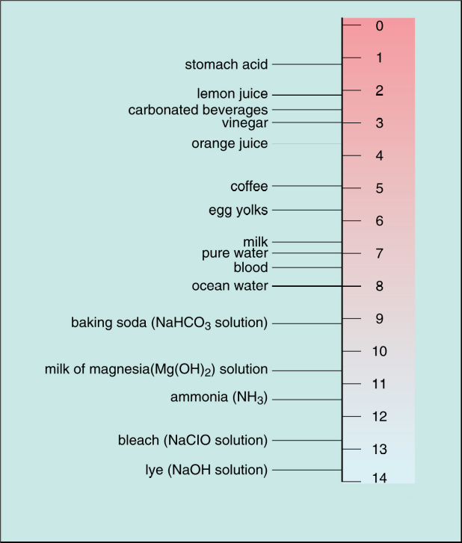

Figure 5: Acidity and the pH Scale
Water has a pH of 7, so this is the point of neutrality on the pH scale. Acids have a pH less than 7, and bases have a pH greater than 7.

Acids
An acid has a higher concentration of hydrogen ions than pure water. For example, when hydrochloric acid (HCl) dissolves in pure water, it donates hydrogen ions (H+) to water molecules, forming hydrogen ions (H+) and chloride ions (Cl-). Strong acids can be harmful to organisms and damaging to materials. Acids have a sour taste and may sting or burn the skin.

Bases
A base has more hydroxide ions (OH-) than does pure water. Like strong acids, strong bases can be harmful to organisms and damaging to materials. Bases have a bitter taste and feel slimy to the touch. They can also
burn the skin.

The polarity of water molecules causes them to form
(a) new elements. (b) hydrogen bonds.
(c) nuclei. (d) solutes.
IV. Organic Compounds

Organic compounds are chemical substances that make up organisms and carry out life processes. All organic compounds contain the elements carbon, hydrogen and oxygen. Because carbon is the major element in organic compounds, it is essential to all known life on Earth. Without carbon, life as we know it could not exist.

The Significance of Carbon
Why is carbon so important to organisms? The answer lies with carbon’s unique properties. Carbon is plentiful on Earth and freely forms covalent bonds. Carbon has an exceptional ability to bind with a wide variety of other elements. Carbon atoms can form multiple stable bonds with other small atoms, including hydrogen, oxygen, and nitrogen. This allows carbon atoms to form a tremendous variety of very large and complex molecules. Most organic compounds contain carbon rings or chains.

Monomers and Polymers
Organic compounds exist as monomers and polymers. If an organic compound is compared to a brick wall, the monomers would be the bricks and the polymer (large organic molecule) would be wall. Monomers are the smallest units of organic compounds, such as sugars. A starch molecule (polymer), is made of hundreds or thousands of sugar molecules. Nearly 10 million carbon-containing organic compounds are known. Types of carbon compounds in organisms include carbohydrates, lipids, proteins, and nucleic acids.

Carbohydrates
Carbohydrates are organic compounds that usually contain only carbon, hydrogen, and oxygen. They will always display a ratio of two hydrogens for each oxygen. They are the most common of the major types of organic compounds. There are thousands of different carbohydrates, but they all consist of one or more smaller units called monosaccharides, or sugars.

The general formula for a simple sugar such as glucose is: C₆H₁₂O₆.
This is the formula for the monosaccharide glucose. Glucose is the major source of energy for living cells.

If more than two monosaccharides bond together, they form a carbohydrate called a polysaccharide. A polysaccharide may contain anywhere from a few monosaccharides to several thousand monosaccharides. Polysaccharides are also called complex carbohydrates. Their main functions are to store energy and form structural tissues. Examples of some carbohydrates and their roles are listed in Table 1.

Table 1: Carbohydrates

Complex Carbohydrate Function Organism
Starch Stores energy Plants
Cellulose Forms cell walls Plants
Glucose Energy for cells Most life forms

Lipids
Lipids are organic compounds that contain mainly carbon, hydrogen, and oxygen. They include substances such as fats and oils. Lipids are nonpolar and thus do not readily mix with water. Lipids are important to living organism as they provide lots of energy, serve as insulation, form some hormones, and phospholipids form cell membrane.

Saturated and Unsaturated Fats
Fats can be saturated or unsaturated. The term saturated refers to the placement of hydrogen atoms around the carbon atoms. In a saturated fat, all the carbon atoms bonded to as many hydrogen atoms as possible. This is why they form straight chains (see Figure 6). Because of this structure, saturated fats can be packed together very tightly. This allows organisms to store chemical energy very densely. The fatty tissues of animals contain mainly saturated fats.
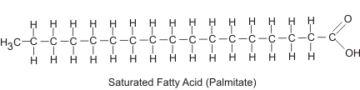
Figure 6: A Saturated Fat. Notice that all carbon atoms in the chain are bonded to hydrogen atoms, resulting in a straight chain.

In an unsaturated fats, some carbon atoms are bonded to one or more additional groups, not hydrogen atoms. Wherever these other groups bind with carbon, they cause the chain to bend. This gives unsaturated fatty acids different properties than saturated fatty acids. For example, unsaturated fatty acids are liquids at room temperature whereas saturated fatty acids are solids. Unsaturated fatty acids are found mainly in plants, especially in fatty tissues such as nuts and seeds. Generally, our diets should consist of more unsaturated fats and fewer saturated fats. However, unsaturated fatty acids can be artificially manufactured to have straight chains like saturated fatty acids. Called trans fats, these synthetic lipids were commonly added to foods, until it was found that they increased the risk for certain health problems.

Lipids and Diet
Humans need lipids for many vital functions, such as storing energy and forming cell membranes. Lipids can also supply cells with energy. In fact, a gram of lipids supplies more than twice as much energy as a gram of carbohydrates or proteins. Although some lipids in the diet are essential, excess dietary lipids can be harmful. Because lipids are very high in energy, eating too many may lead to unhealthy weight gain. A diet high in saturated fats also seems increase the risk for health problems such as heart disease. The dietary lipids of most concern are saturated fatty acids, trans fats, and cholesterol. For example, cholesterol is the lipid mainly responsible for narrowing arteries and causing the disease atherosclerosis.

Proteins
Proteins are organic compounds that contain carbon, hydrogen, oxygen, nitrogen, and, in some cases, sulfur. Proteins (polymers) are made of smaller units (monomers) called amino acids. There are 20 different common amino acids.

Functions of Proteins
Proteins are an essential part of all organisms. They play many roles in living things. Certain proteins provide a scaffolding that maintains the shape of cells. Proteins also make up the majority of muscle tissues. Many proteins are enzymes that speed up chemical reactions in cells. Other proteins are antibodies. They bond to foreign substances in the body and target them for destruction, forming a vital link in our ability to fight off disease. Still other proteins help carry messages or materials in and out of cells or around the body. For example, the blood protein hemoglobin bonds with oxygen and carries it from the lungs to cells throughout the body.

Proteins and Diet
Proteins in the diet are necessary for life. Dietary proteins are broken down into their component amino acids when food is digested. Cells can then use the components to build new proteins. Humans are able to synthesize all but eight of the twenty common amino acids. These eight amino acids, called essential amino acids, must be consumed in foods. Like dietary carbohydrates and lipids, dietary proteins can also be broken down to provide cells with energy.

Nucleic Acids
Nucleic acids are organic compounds that contain carbon, hydrogen, oxygen, nitrogen, and phosphorus.
They are made of smaller units called nucleotides. Nucleic acids are named for the nucleus of the cell,
where some of them are found. Nucleic acids are found not only in all living cells but also in viruses. Types
of nucleic acids include deoxyribonucleic acid (DNA) and ribonucleic acid (RNA). The role of nucleic acids is to store and transmit genetic information.

Which carbohydrate is not a simple sugar?
(a) fructose (b) sucrose (c) glucose (d) starch

V. Enzymes and Biochemical Reactions

Most chemical reactions within organisms would be impossible under the conditions in cells. For example, the body temperature of most organisms is too low for reactions to occur quickly enough to carry out life processes. Reactants may also be present in such low concentrations that it is unlikely they will meet and collide. Therefore, the rate of most biochemical reactions must be increased by a catalyst. A catalyst is a chemical that speeds up chemical reactions without being consumed in the reaction. In organisms, catalysts are called enzymes. Like other catalysts, enzymes are not reactants in the reactions they control. They help the reactants interact but are not used up in the reactions. Instead, they may be used over and over again. Unlike other catalysts, enzymes are usually highly specific for particular chemical reactions. They generally catalyze only one or a few types of reactions.

Enzymes are extremely efficient in speeding up reactions. They can catalyze up to several million reactions per second. As a result, the difference in rates of biochemical reactions with and without enzymes may be enormous. A typical biochemical reaction might take hours or even days to occur under normal cellular conditions without an enzyme but less than a second with the enzyme.

How Enzymes Work
How do enzymes speed up biochemical reactions so dramatically? Like all catalysts, enzymes work by lowering the activation energy of chemical reactions. This is illustrated in Figure 7. The biochemical reaction shown in the figure requires about three times as much activation energy without the enzyme as it does with the enzyme.

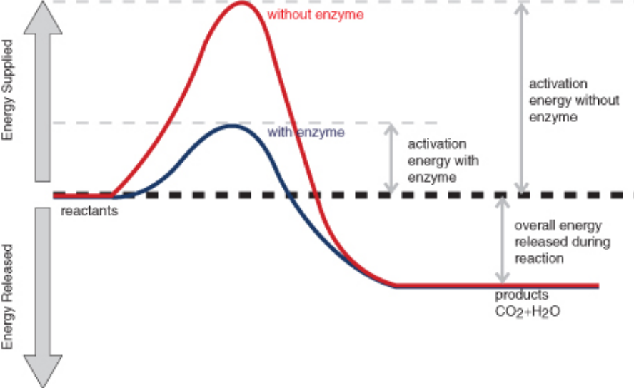
Figure 7: The Effect of Enzymes on Reactions: The reaction represented by this graph is respiration, where energy is released from glucose. The reactants are glucose (C₆H₁₂O₆) and oxygen (O₂). The products of the reaction are carbon dioxide (CO₂) and water (H₂O). Energy is also released during the reaction. The enzyme speeds up the reaction by lowering the activation energy needed for the reaction to start. Compare the activation energy with and without the enzyme.

Enzymes generally lower activation energy by reducing the energy needed for reactants to come together and react. For example:

• Enzymes bring reactants together so they don’t have to expend energy moving about until they collide at random. Enzymes bind both reactant molecules, tightly and specifically, at a site on the enzyme molecule called the active site (see Figure 8).

• By binding reactants at the active site, enzymes also position reactants correctly, so they do not have to overcome intermolecular forces that would otherwise push them apart. This allows the molecules to interact with less energy.

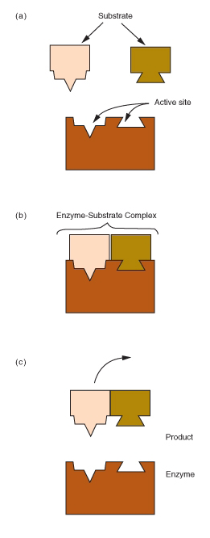

Figure 8: Enzyme Action: This enzyme molecule binds reactant molecules—called substrate—at its active site, forming an enzyme-substrate complex. This brings the reactants together and positions them correctly so the reaction can occur. After the reaction, the products are released from the enzyme’s active site. This frees up the enzyme so it can catalyze additional reactions.

Importance of Enzymes
Enzymes are involved in most of the chemical reactions that take place in organisms. About 4,000 such reactions are known to be catalyzed by enzymes, but the number may be even higher. Needed for reactions that regulate cells, enzymes allow movement, transport materials around the body, and move substances in and out of cells. In animals, another important function of enzymes is to help digest food. Digestive enzymes speed up reactions that break down large molecules of carbohydrates, proteins, and fats into smaller molecules the body can use. Without digestive enzymes, animals would not be able to break down food molecules quickly enough to provide the energy and nutrients they need to survive. You have likely heard of the condition known as lactose intolerance, where an individual is unable to digest the milk sugar lactose. Such individuals lack the enzyme lactase, used in the intestines to digest lactose sugars.

A catalyst is any chemical that
(a) is present at the start of a chemical reaction.
(b) is produced during a chemical reaction.
(c) binds with an enzyme in a chemical reaction.
(d) speeds up a chemical reaction.

A chemical reaction catalyzed by an enzyme requires
(a) fewer reactants (b) more products.
(c) less activation energy. (d) more chemical bonds.

Sources:
Text: FlexBook: ck-12 Biology (August 2010)
Figure 1. (Source:http:// commons.wikimedia.org /wiki/Image: Stylised_Lithium_ Atom.png, License:
Creative Commons)
Figure 2. (Source: http://en.wikipedia.org/wiki/ Image:Water_molecule.svg, License: Creative Commons)
Figure 3 (Source: http://en.wikipedia.org /wiki/Image:Water-elpot-transparent-3D-balls.png, License:
GNU-FDL)
Figure 4 (Source: http://en.wikipedia.org/wiki/Image:Liquid_water_hydrogen_bond.png, License: GNU-
FDL)
Figure 5 (Source: http://upload.wikimedia.org /wikipedia/ commons/4/ 46/PH_scale. png, License: GNU
FDL)
Figure 6 (Source: http://commons.wikimedia.org/wiki/ File:Fatty_acids.png License: GNU
FDL)
Figure 7 (Source: http://en.wikipedia.org/wiki/Image:Activation2_updated.svg, License: GNU-FDL)
Figure 8 (Source: CK-12 Foundation, License: CC-BY-SA)
Vocabulary

Acid: Solution with a higher hydrogen ion concentration than pure water and a pH lower than 7.
Activation Energy: Energy needed for a chemical reaction to get started.
Adhesion: Tendency of a substance, such as water, to stick to other substances.
Amino Acid: Small organic molecule that is a building block of proteins.
Base: Solution with a lower concentration of hydrogen ions/ more OH- ion than water and a pH above 7.
Carbohydrate: Type of organic compound that consists of one or more smaller units called
monosaccharides.
Catalyst: A chemical that speeds up chemical reactions without being consumed in the reaction.
Chemical Compound: Unique substance with a fixed composition that forms when atoms of two or more
elements react.
Chemical Reaction: Process that changes some chemical substances into other chemical substances.
Cohesion: Tendancy of a substance, such as water, to stick to other molecules of the same substance.
Complex Carbohydrate: Another term for a polysaccharide.
Covalent Bond: Sharing of electrons between two nonmetal atoms.
Element: Pure substance made up of just one type of atom.
Enzyme: Organic molecule that speeds up chemical reactions; biological catalyst.
Hydrogen Bond: Bond that forms between a hydrogen atom in one molecule and a different atom in
another molecule.
Ion: Electrically charged atom or molecule.
Ionic Bond: Bond between a metal and nonmetal; ions are largely donated, not shared.
Kinetic Energy: Form of energy that an object has when it is moving.
Lipid: Type of organic compound
that consists of one or more fatty acids with or without additional molecules.
Law of Conservation of Energy: Energy can never be created or destroyed; it can only be transformed.
Law of Conservation of Matter: Matter can never be created or destroyed.
Monosaccharide: Small carbohydrate, such as glucose, with the general formula (CH₂O)n.
Nucleic Acids: Organic compounds that contain carbon, hydrogen, oxygen, nitrogen, and phosphorus; store
and transmit genetic information.
Nucleotides: The monomers (building blocks) of nucleic acids (DNA and RNA).
Organic Compound: Type of chemical compound that contains carbon, hydrogen and oxygen; found
mainly in organisms.
pH: Measure of the acidity, or hydronium ion concentration, of a solution.
Phospholipid: Type of lipid that is a major component of cell membranes.
Polar Molecule: Molecule with differences in electrical charge between different parts of the molecule.
Polysaccharide: Large carbohydrate that consists of more than two monosaccharides.
Potential Energy: Form of energy that is stored in an object due to its position.
Product: Substance that forms as a result of a chemical reaction.
Protein: Type of organic compound that consists of smaller units called amino acids.
Reactant: Substance involved in a chemical reaction that is present at the beginning of the reaction.
Saturated Fat: Type of fat in which all the carbon atoms are bonded to as many hydrogen atoms as possible.
Sugar: Another term for a monosaccharide or disaccharide.
Solute Substance in a solution that is dissolved by the other substance (the solvent).
Solution Homogeneous mixture in which one substance is dissolved in another.
Solvent Substance in a solution that dissolves the other substance (the solute).
Trans Fat: Artificial, unsaturated fat that has properties similar to saturated fatty acids.
Unsaturated Fat: Type of fat in which some carbon atoms are not bonded to as many
hydrogen atoms as possible

